ASSIGNMENT 06.4

VIDHU SREE DAYYALA - 2303A52400 - BATCH 41

Task 1: Student Performance Evaluation System
PROMPT:
Class student with attributes name, roll number, marks and methods to display details and other to check whether the marks is above avg of class or not
CODE:
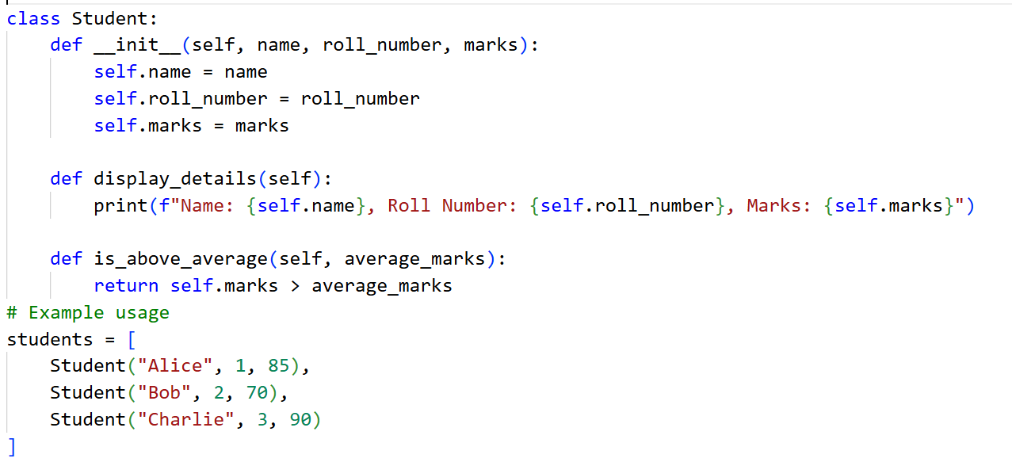
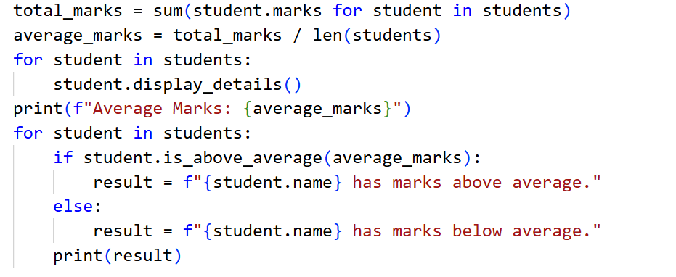
OUTPUT:
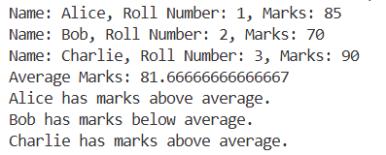
JUSTIFICATION:
By this task, we can calculate the total average marks of the class and then we can also find the students who are scoring more than the average marks and also the students who are scoring the students with below average marks

Task 2: Data Processing in a Monitoring System
PROMPT:
Read a list of numbers from user and print square of even numbers
CODE:
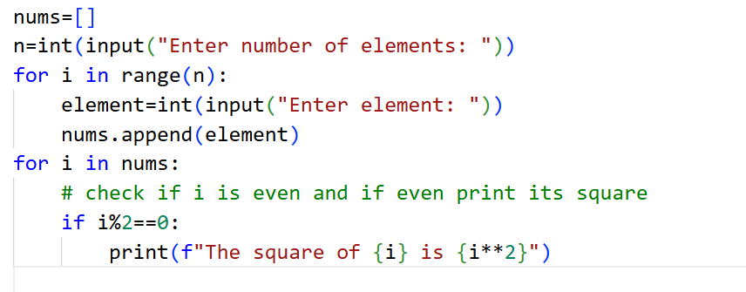
OUTPUT:
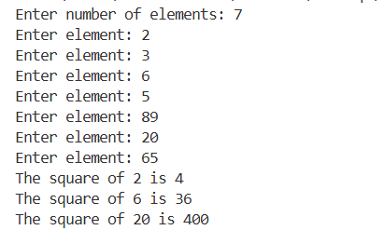
JUSTIFICATION:
In this task we are calculating the squares of even numbers present in out list. By this task we are able to traverse the list fully and perform the required actions. Not only giving the prompt in the very start, we are also giving prompt in form of commets.

Task 3: Banking Transaction Simulation
PROMPT:
Class bank account with attributes account holder name, balance and methods to deposit amount, withdraw amount and display balance
CODE:
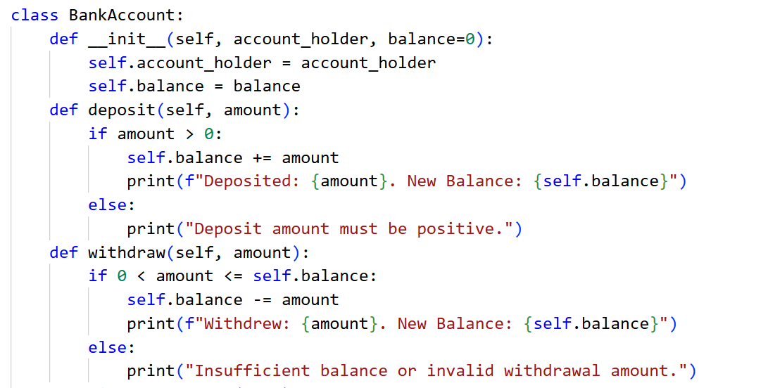
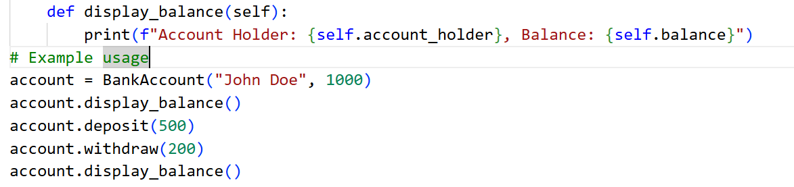
OUTPUT:
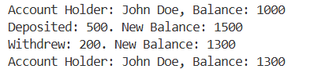
JUSTIFICATION:
By this task we are able to construct the fully working class BankAccount with required methods mentioned and we have full-filled all the required outcomes expected like if-else condition, invalid withdraw options.
Task 4: Student Scholarship Eligibility Check
PROMPT:
Create a list of dictionaries with name, student and print students with marks more than 75 with while loop
CODE:
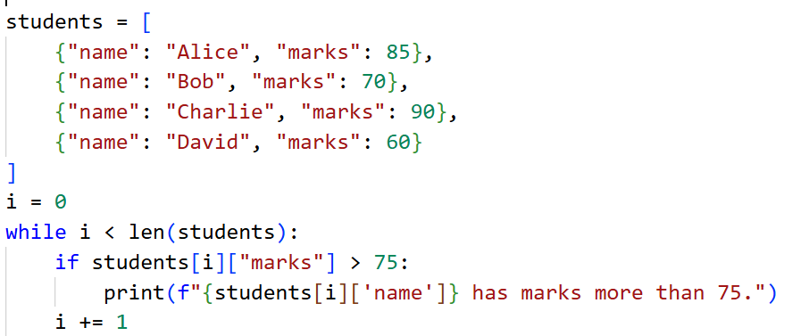
OUTPUT:
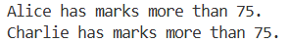
JUSTIFICATION:
In this task, we are iterating using while loop and printing only the students who has the meet with the required requirements like scoring above 75 marks. By this code we are completing the required task

Task 5: Online Shopping Cart Module
PROMPT:
Prompts are given in comments;
- Initialize the shopping cart with an empty list of items
- Method to add an item to the cart
- Method to remove an item from the cart
- Method to calculate the total price of items in the car
- Apply discount if total price is more than 500
CODE:
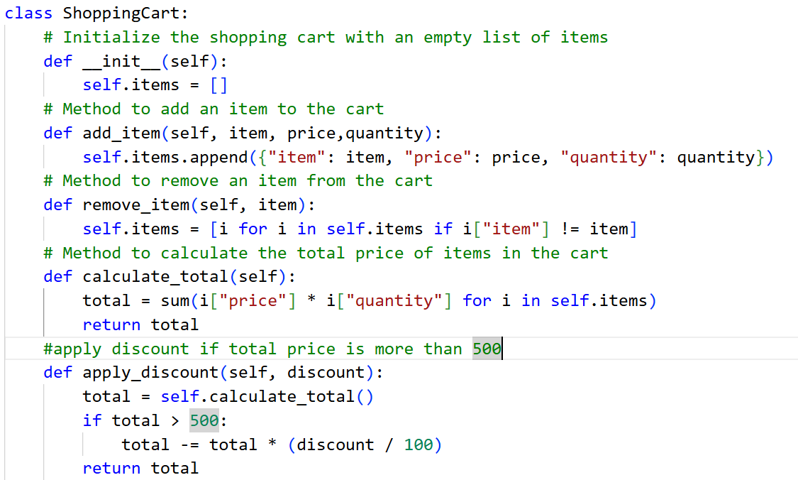
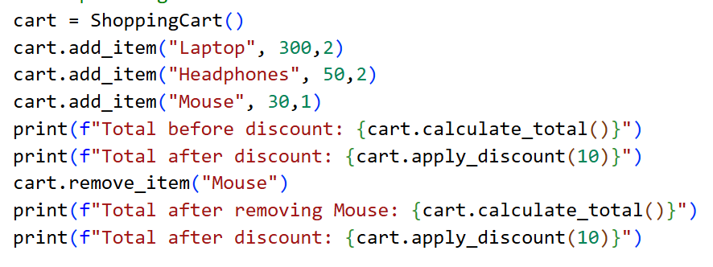
OUTPUT:
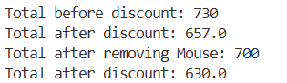
JUSTIFICATION:
Unlike all the other tasks, in this task we are giving the prompt in comments after starting of code. Previously we are giving the prompt in the very start of the code but now, in this code we are giving the prompt in middle of code and making our code as required for us.

